You are given an n x n 2D matrix representing an image, rotate the image by **90** degrees (clockwise).

You have to rotate the image [**in-place**](https://en.wikipedia.org/wiki/In-place_algorithm), which means you have to modify the input 2D matrix directly. **DO NOT** allocate another 2D matrix and do the rotation.

**Example 1:**

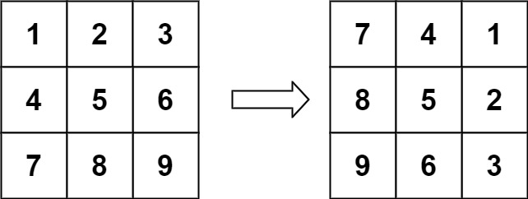

Input: matrix = [[1,2,3],[4,5,6],[7,8,9]]  
Output: [[7,4,1],[8,5,2],[9,6,3]]

**Example 2:**

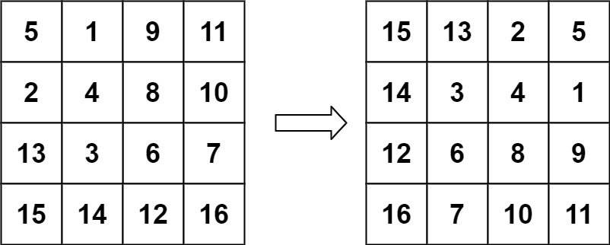

Input: matrix = [[5,1,9,11],[2,4,8,10],[13,3,6,7],[15,14,12,16]]  
Output: [[15,13,2,5],[14,3,4,1],[12,6,8,9],[16,7,10,11]]

**Constraints:**

* n == matrix.length == matrix[i].length
* 1 <= n <= 20
* -1000 <= matrix[i][j] <= 1000